FRED FOGARTY -
The forgotten hero of the land rights struggle.
By Dr Bill Day
Darwin
2010
\
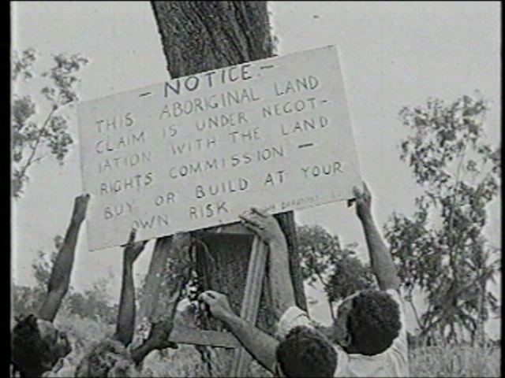

Above: Aborigines replace a sign at Ostermann Street, Coconut Grove, in the weeks before the firebombing of a surveyor’s truck on July 6, 1973.

